Digital circuits

Short quiz 1

- What is meant by the term analog, with regards to an electronic circuit?

- What is meant by the term digital, with regards to an electronic circuit?

- A NOT circuit is also called a/an ………………………

4.
INPUT |  |  | OUTPUT
C | B | A | Y
0 | 0 | 0 | 0
0 | 0 | 1 | 0
0 | 1 | 0 | 0
0 | 1 | 1 | 0
1 | 0 | 0 | 1
1 | 0 | 1 | 0
1 | 1 | 0 | 0
1 | 1 | 1 | 1

Let us assume that we are designing a simple electronic lock. The lock will open only when certain switches are activated. The figure above is a truth table for the electronic lock. Notice that there are two valuations for input switches A, B and C that generate a 1 at the output. A 1 at the output will open the lock.

- Write the Boolean expression
- Draw the Logic circuit

5. A certain application requires that two lines be monitored for the occurrence of a HIGH level voltage on either or both lines. Upon detection of a HIGH level, the circuit must provide a LOW voltage to energize an alarm circuit.

- Design the truth table
- Write the Boolean expression
- Draw the Logic circuit

6. The logic circuit shown below is used to turn on a warning buzzer at “X” based on the input conditions at A, B, and C. A simplified equivalent circuit that will perform the same function can be formed by using Boolean algebra. Write the equation of the circuit, simplify the equation and draw the logic circuit of the simplified equation.
B

B
B(A+C)
A
C
X

7. Write the Boolean logic equation and draw the logic circuit that represents the following function:
A Bank burglar alarm (A) is to activate if it is after Banking hours (H) and the front door (F) is opened or if it is after Banking hours (H) and the vault door (V) is opened.

The logic level of the variable H is “1” after Banking hours and “0” during Banking hours. F is “1” if the door sensing switch is open and “0” if the door sensing switch is closed. V is “1” if the vault sensing switch is open and “0” if the vault sensing switch is closed.

- Using Boolean algebra, reduce the logic function described to a simpler form and sketch the resulting circuit.
- If a burglar named Freshman, who has studied Boolean algebra, wants to rob the Bank by tampering with the sensors to prevent the alarm from going off, what would be the easiest way? Explain your answer.

8. Show that the following four circuits are identical in function.

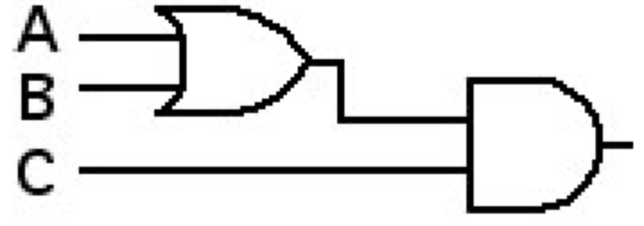

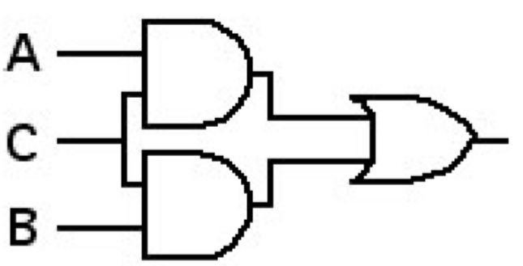

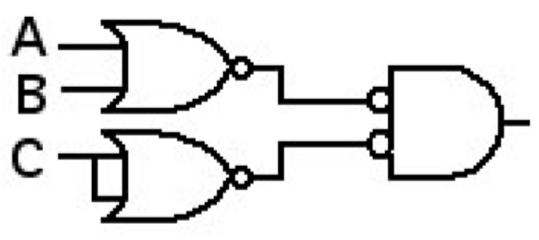
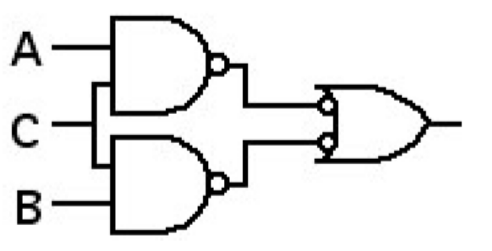

Single-Variable Theorems
1a.
1b.
2a.
2b.
3a.
3b.
4a.
4b.
5.
Two-and Three-Variable Properties
1a. Cumulative
1b.
2a. Associative
2b.
3a. Distributive
3b.
4a. Absorption
4b.
5a. Combining
5b.
6a. DeMorgan’s Theorem
6b.
7a.
7b.
8a. Consensus
8b.

